**TestNg Emailable Report**

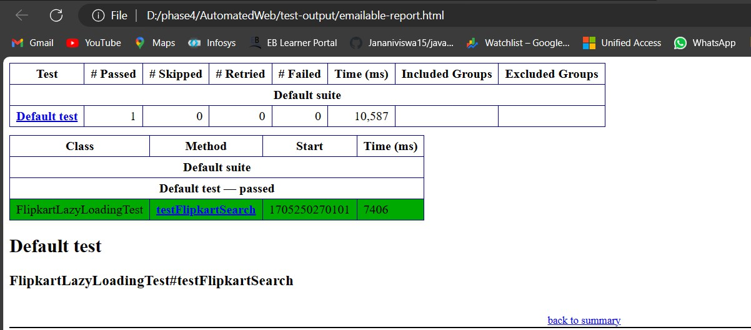

**TestNg Index page**

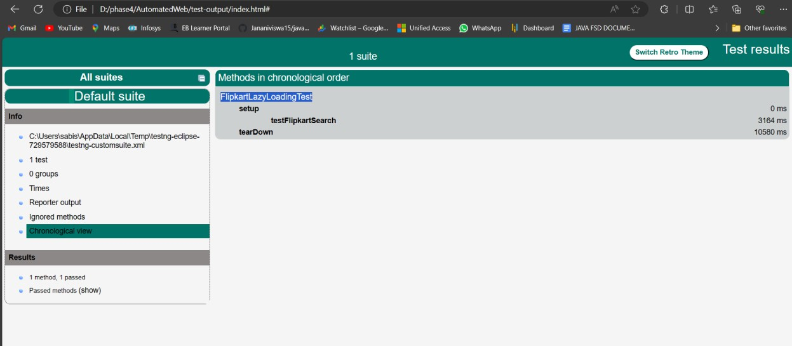

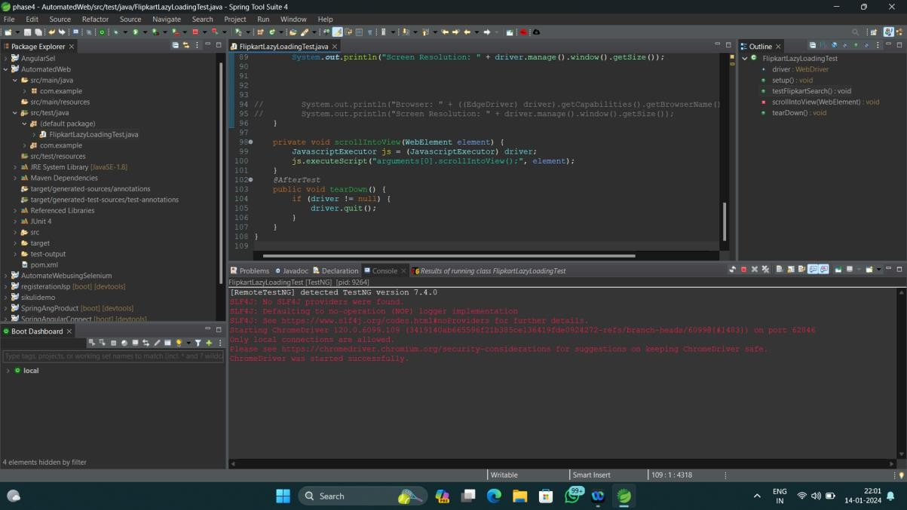

* 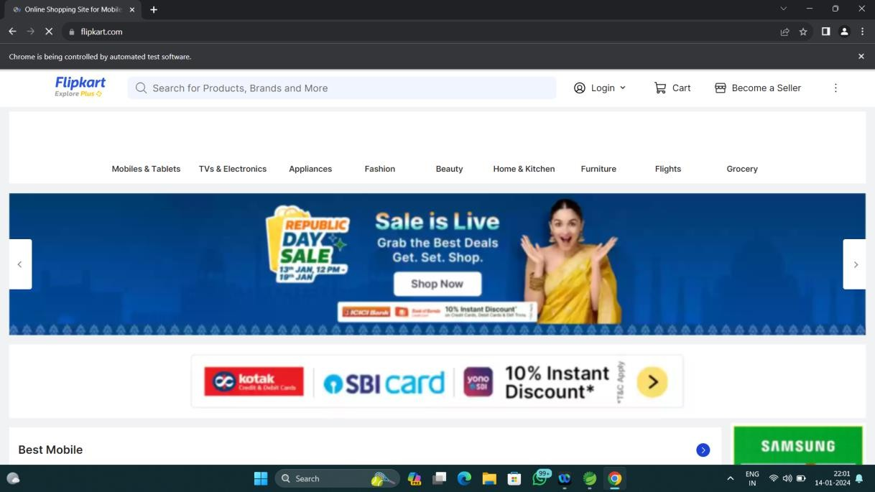Navigate to the Flipkart homepage (<https://www.flipkart.com/>)
* Determine a page load time with a performance test
* 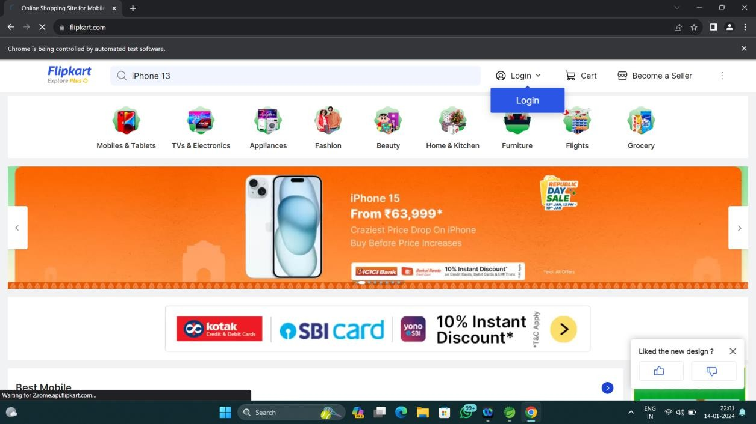Search for a product, say, “iPhone 13” under the “Mobile” category
* Check if the images are loaded and visible till the screen height only



* Check if the page has a scroll feature

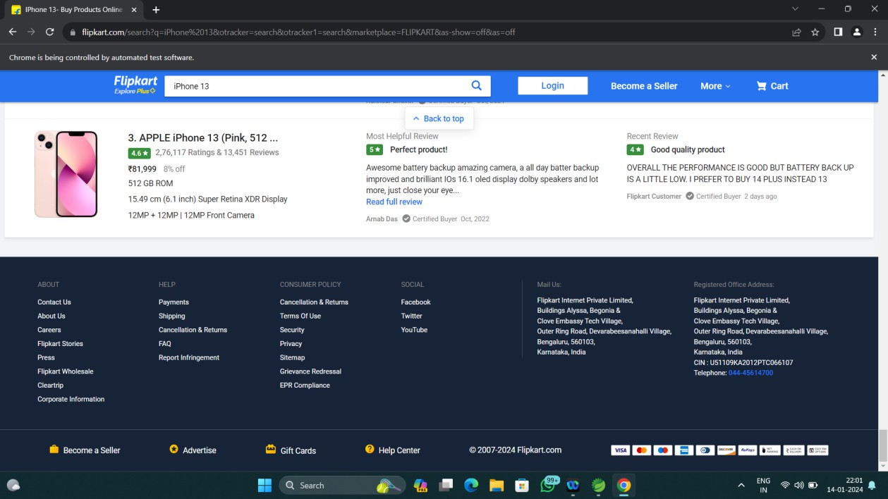

* Check the frequency at which the content will be refreshed while scrolling



* Verify that the image is downloaded just before the user scrolls to its position and gets displayed in time

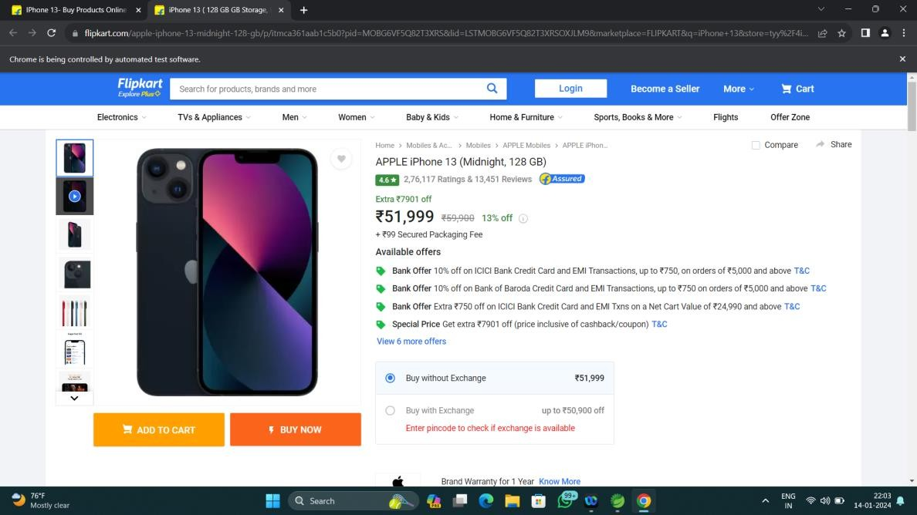

* Check whether different browsers and screen resolutions render it the same way

|  |  |
| --- | --- |
| ChromeDriver | EdgeDriver |
|  |  |